**Title of Thesis**

A thesis presented in partial fulfilment of the requirements for the degree of

Master of Information Technology

At Whitireia Polytechnic, Porirua | Auckland, New Zealand

[Full name of author]

[Year of final grading]

# Abstract

This document gives a general outline of a design science thesis. It offers some guidance on how to caption figures, insert tables of contents, and how to lay out the thesis. Some general guidelines as to what should be included in each section is also included. All of the suggestions contained here should be discussed with your supervisor and can be varied depending on the nature of the project.

The abstract should summarise the entire study as briefly as possible. Generally no more than 250-300 words are required.

# Acknowledgements

You should acknowledge those that helped you with your research, usually including your supervisor/s.

Table Of Contents

Abstract ii

Dedication iv

Acknowledgements v

List of Tables vii

List of Figures viii

List of Symbols ix

List of Abbreviations x

CHAPTER 1 INTRODUCTION 1

1.1 Overview of The Study 1

1.2 Significance of The Study 1

1.3 Research Problem 1

1.4 Scope of Study 1

1.5 Research Questions 1

1.6 Research Objectives 2

1.7 Thesis Organisation 2

CHAPTER 2 LITERATURE REVIEW 3

2.1 Insert Headings 3

2.1.1 How to insert Headings? 3

2.2 Edit the Paragraph 3

2.3 Insert Figures and Tables 3

2.3.1 How to insert Figures and Tables? 3

2.4 Insert Table of Contents 5

2.5 Insert List of Figures and List of Tables 6

2.6 Whitireia Porirua Campus 9

2.6.1 Library 9

2.6.2 The Centre of of Porirua Campus 9

2.7 Example of Refernces in APA Format 10

2.8 Summary 10

CHAPTER 3 Methodology 11

3.1 Introduction 11

3.2 Description 11

3.3 Summary 11

CHAPTER 4 EXPERIMENTAL RESULTS AND DISCUSSION 12

4.1 Introduction 12

4.2 Experimental Results 13

4.3 Discussion 13

4.4 Summary 13

CHAPTER 5 CONCLUSION AND FUTURE WORK 14

5.1 Conclusion 14

5.2 Recommandations and Future Work 14

BIBLIOGRAPHY 15

APPENDICES 16

Appendix A 16

Appendix B 17

# List of Tables

Table No. Page No.

**No table of figures entries found.**

# List of Figures

Figure No. Page No.

Figure 2‑1: Thesis Headings 3

Figure 2‑2: How to insert caption 4

Figure 2‑3: How to change caption numbering 4

Figure 2‑4: Insert Tab with Cross Reference 5

Figure 2‑5: Selecting Cross References 5

Figure 2‑6: How to change caption numbering 6

Figure 2‑7: How to update Table of Contents 6

Figure 2‑8: How to update Table of Contents 7

Figure 2‑9: How to update Table of Contents 7

# List of Symbols

Only include this section if you have symbols.

# List of Abbreviations

Information Technology IT

# INTRODUCTION

## Overview of this template

1. This template is ready to use in terms of margins as the top, bottom and right is 0.79” and left is 1.58”. The pages should be mirror margined to facilitate printing.
2. You should use double line spacing and either Times New Roman, Calibri or a similar standard font.
3. Page numbering starts from Chapter One as Page 1. Any pages’ numbering appear before Chapter One should be in Roman script.
4. New Zealand English is preferred. You can use American English but what ever you chose be consistent.
5. To see the thesis organisation, press View and then tick Navigation pane. A list will appear at your left hand side where you can move from one chapter to another easily through headings and subheadings.
6. Please download Grammarly from

<https://www.grammarly.com/office-addin/signup> to assist you in grammar. The Grammarly icon won’t appear on the top of the word document until you install it in your PC.

## What should be in the introduction

The introduction should describe the general problem, and give an overview of the research so the reader can understand the context of your research, the issues it addresses and the contribution of the research. The headings following this section should also be included.

## Significance of The Study

## Scope of Study

## Research Problem

## Research Questions

## Research Objectives

## Thesis Organisation

This section should outline what is in each chapter of the rest of the thesis. Chapter 1 provides an overview of this research followed by research significance and the problem statements. This chapter also presents the objectives and the scope of the research.

Chapter 2

Chapter 3

Chapter 4

Chapter 5

# LITERATURE REVIEW

## What should be in the literature review

The literature review gives the reader a background and context for your research. It also proves to the reader that you understand research in your topic area. You should start from the most general concepts in your topic area and move to the most specific concepts.

## Inserting Headings

Headings can be found at the top of the page on the Home tab from Heading1 to Heading 7 as shown in Figure 2-1.

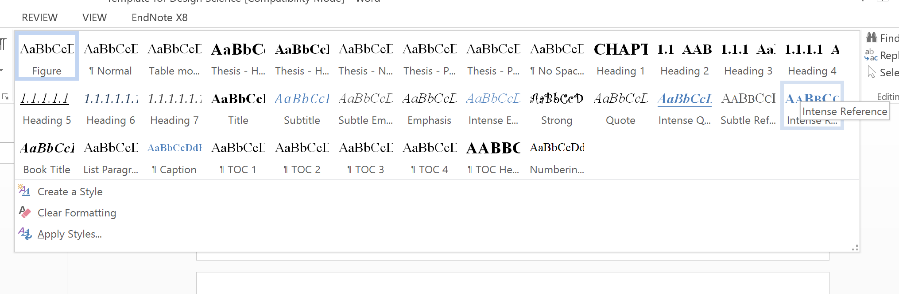

Figure 2‑1: Thesis Headings

### How to insert Headings?

1. Type your heading as normal text.
2. Highlight the text and choose which Heading you want from the Headings list. If you want a subheading you have to choose from Heading 2 to Heading 7. Heading 1 is only used for the Chapter Title.

## Inserting Figures and Tables

### How to insert Figures and Tables?

Every table, figure, graph and diagram must have a caption, and they must also be referred to and described in the text of your thesis.

1. Highlight your figure or table
2. Open the References tab
3. Press Insert Caption as shown in Figure 2-2

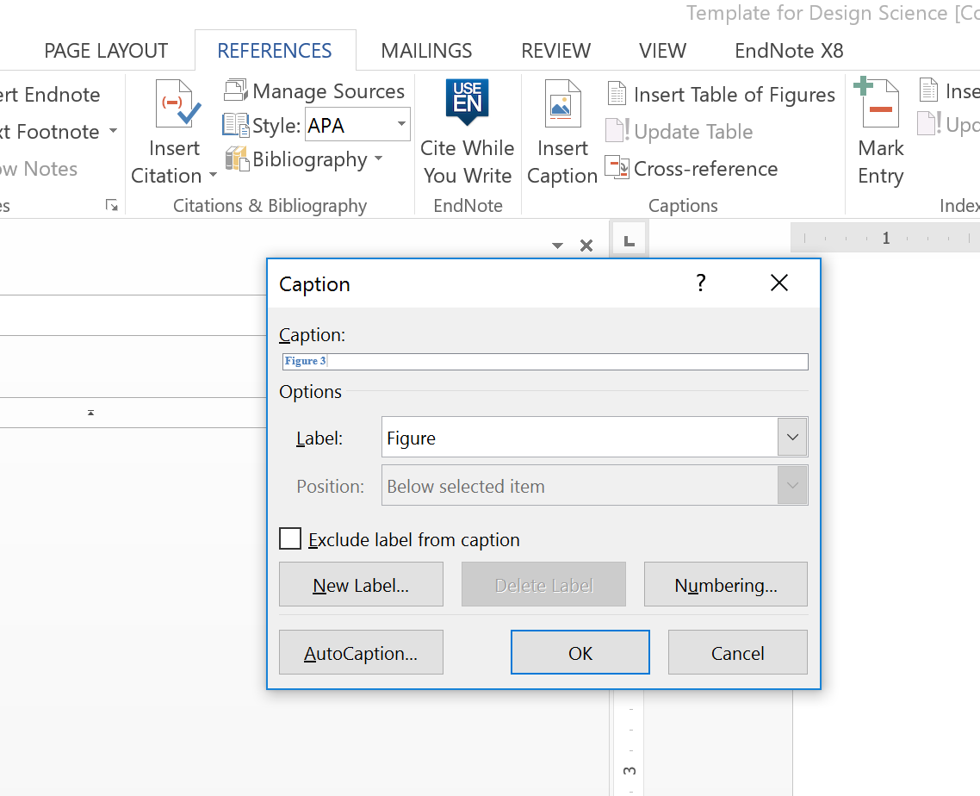

Figure 2‑2: How to insert caption

1. Choose to change numbering by ticking include chapter number under the “Numbering…” box

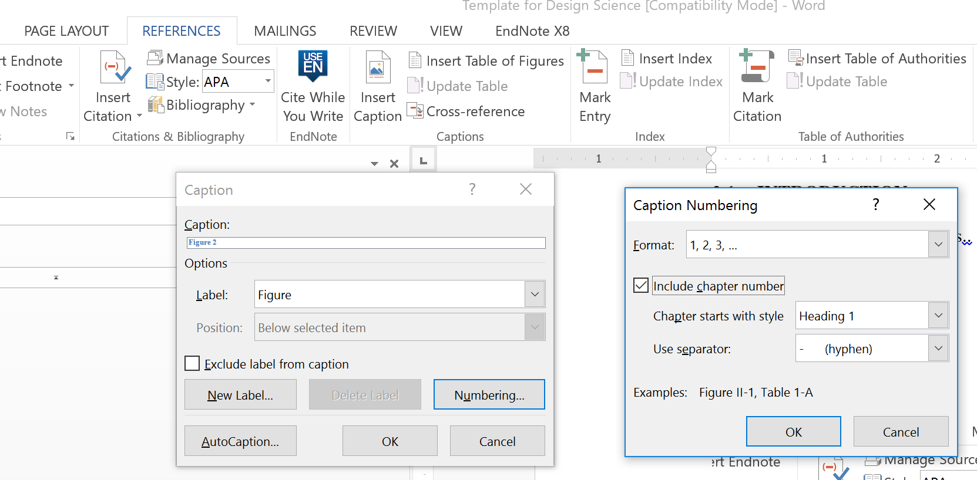

Figure 2‑3: How to change caption numbering

1. Under Options/Label chose either Figure or Table. Make sure Figure or Table also appear in blue in the Caption box – then add your figure or table name after the figure or table number.

## Linking (cross referencing) to figure/table captions in text

It is possible to link the in text table or figure number to the number in the caption of the associated table or figure. This has the advantage if your table/figure number updates it will update in text as well.

1. In your document place the cursor where you want to insert the cross reference the chose Insert Cross Reference from the Insert tab

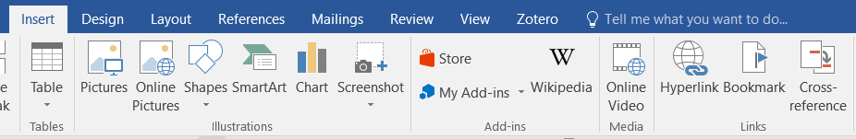

Figure 2‑4: Insert Tab with Cross Reference

1. Then select Figure or Table from the drop down menu, and then click on the figure or table you want to cross reference to.

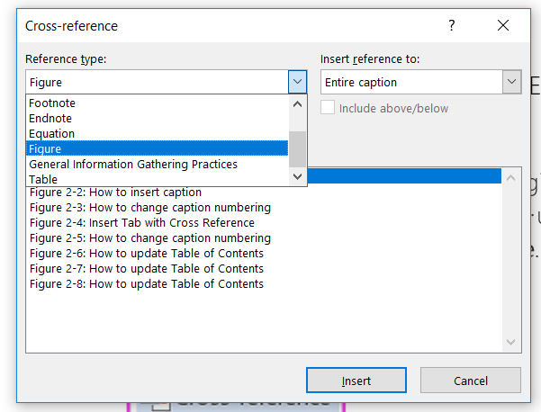

Figure 2‑5: Selecting Cross References

1. You can update the field in text by clicking into the link (so you don’t have to use the exact name of the figure/table if you don’t want to).
2. You might find you have to right mouse click on the links in text, order to update the numbers.

## Insert Table of Contents

The table of contents that appears in page **vii** is ready to use.

If you add a new heading or subheadings you need to update the Current Table of Contents as follows:

1. Right click on the Table of contents as shown in Figure 2-4.

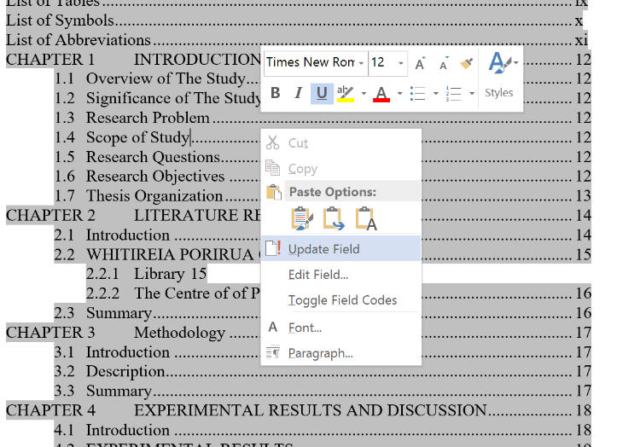

Figure 2‑6: How to change caption numbering

1. Press Update Field and choose Update Entire Table to update the page numbering as well.

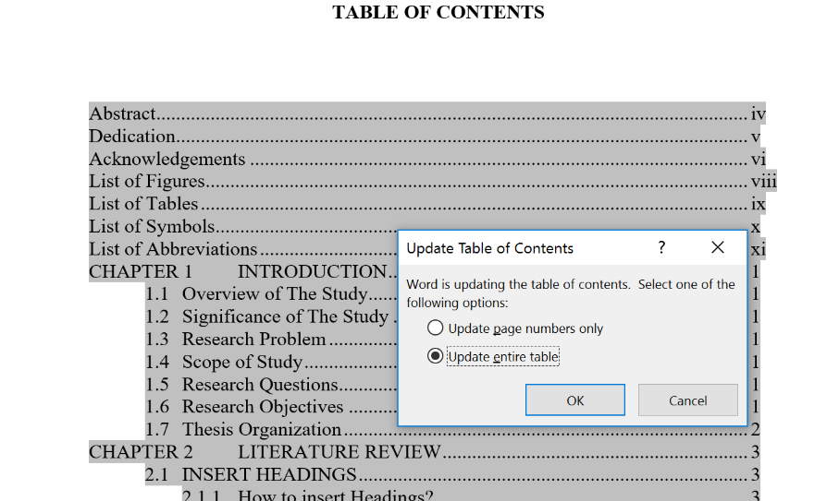

Figure 2‑7: How to update Table of Contents

## Insert List of Figures and List of Tables

The current list of Figures can be updated in the same way as the Table of Contents by right click on the mouse and click the update button. Otherwise, to insert a new List of Figures you do the followings:

1. In the References tab, click Insert Table of Figures as shown in Figure 2-6.

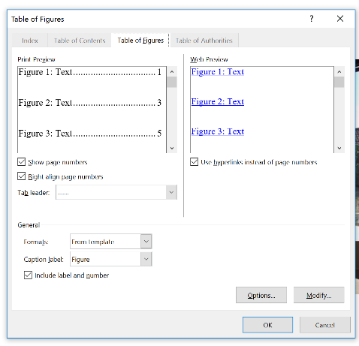

Figure 2‑8: How to update Table of Contents

1. You can adjust the tab leader and many other features.
2. If you want to insert List of Tables please see Figure 2-7.

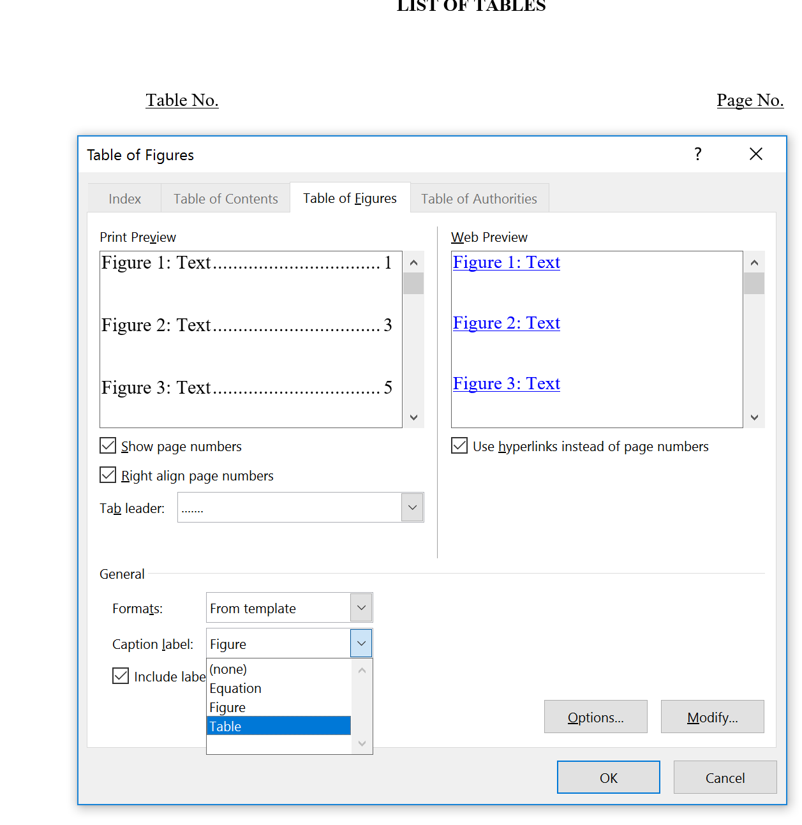

Figure 2‑9: How to update Table of Contents

## Summary

Each chapter should end with a summary approximately a paragraph long.

# METHODOLOGY

## What should be in methodology

Methodology should include a comprehensive description of how you did your research. It may also include a justification for the methods you chose. Don’t forget the small details of methodology as these are important. The following sections should be included in methodology:

## Introduction

## methodology

You should outline the design science methodology including the nature of the artefact, describe the artefact, and how is the artefact going to be evaluated.

## Summary

# EXPERIMENTAL RESULTS AND DISCUSSION

## What should be in results and discussion

Results and discussion will likely be combined in a design science thesis. Each result should be described, and then discussed in relation to the literature and what is already known. The differences from the literature should be highlighted, along with pointing out where new knowledge and understanding has been created. Work through each result and try to avoid mixing results and discussion together. Findings (or results) should be findings, then discussion separately. The discussion should tie the results together.

## Introduction

## Experimental Results

## Discussion

Discussion can also be a separate chapter.

## Summary

# CONCLUSION AND FUTURE WORK

## What should be in the conclusion

Sometimes conclusion is combined with discussion – but never with findings. So you might have a findings and discussion chapter then a conclusion; or a findings chapter and a then a discussion and conclusion chapter; or all three could be separate chapters.

You should answer your research question in the conclusion (or in the discussion if there is no conclusion) along with recommendations for future work, limitations and contribution. The following sections should be present in your conclusion section:

## Conclusion

In this paragraph, the researcher should summaries the research work and emphasis on contribution to the field of the research.

## Recommandations and Future Work

All the research work on the current topic that can be taken to future work should be written in this section.

## Limitations

Your research will also have some limitations, these should be acknowledged here.

# REFERENCES

Your references should be in an appropriate academic format, either APA style 6th or 7th edition, or IEEE (or a similar style).

Bui, Y. N. (2014). *How to write a master’s thesis* (2nd ed.). Sage.

# APPENDICES

# Appendix A

Appendices should include experimental results where they are in the form of tables and figures. Copies of ethics approvals, questionnaires, email invitations to participate and other documents used during the study.